Safaan Hashmi

Lecture 5 11-Aug-2024

Practice Problems

**1. Write a java program to implement single level inheritance.**

class Main {

public static void main(String args[]) {

Student_Name p = new Student_Name();

p.Fee();

p.Name();

}

}

class Student{

void Fee() {

System.out.println("Student Fee= 20000");

}

}

class Student_Name extends Student{

void Name() {

System.out.println("Student Name=Jayanti");

}

}

OUTPUT -:

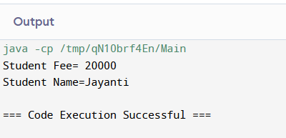

**2. Write a java program to implement method overriding.**

class Main {

public static void main(String[] args) {

Dog d1 = new Dog();

d1.displayInfo();

}

}

class Animal {

public void displayInfo() {

System.out.println("I am an animal.");

}

}

class Dog extends Animal {

@Override

public void displayInfo() {

System.out.println("I am a dog.");

}

}

OUTPUT -:

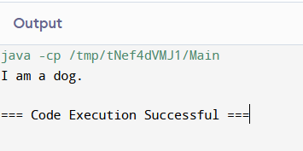

**3. Write a java program to demonstrate the implementation of abstract class.**

class Main extends Language {

public static void main(String[] args) {

Main obj = new Main();

obj.display();

}

}

abstract class Language {

public void display() {

System.out.println("This is Java Programming");

}

}

OUTPUT -:

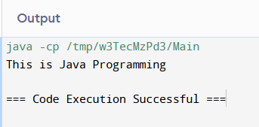

**4. Design a class that demonstrates the use of constructor and destructor.**

public class MyClass {

// Constructor

public MyClass() {

System.out.println("Constructor called: Object created.");

}

public void cleanup() {

System.out.println("Cleanup called: Resources released.");

}

@Override

protected void finalize() throws Throwable {

try {

System.out.println("Finalize called: Object is being collected.");

} finally {

super.finalize();

}

}

public static void main(String[] args) {

MyClass obj = new MyClass();

obj.cleanup();

obj = null;

System.gc();

}

}

Output -:

